Movie Ticket Booking System

# 1. Introduction

## Team Details

The following table includes the team member details.

|  |  |  |
| --- | --- | --- |
| Name | Roll No | Email |
| SVN Sai Sathvik | IMT2023001 | [SVN.Sathvik@iiitb.ac.in](mailto:SVN.Sathvik@iiitb.ac.in) |
| Kh Sudhir | IMT2023546 | <Kh.Sudhir@iiitb.ac.in> |
| Kasam Likith  K Jitin  Sai Ganesh  Kapil Aditya Reddy | IMT2023573  IMT2023057  IMT2023525  IMT2023052 | [Likith.Kasam@iiitb.ac.in](mailto:Likith.Kasam@iiitb.ac.in)  <KVS.Jitin@iiitb.ac.in>  <Ganesh.Upadrasta@iiitb.ac.in>  <KKR.Aditya@iiitb.ac.in> |

## Project Overview

## The Movie Booking System is a terminal-based application developed to streamline the process of booking movie tickets. Leveraging the interoperability between C++ and Java via JNI, the system provides an efficient and modular design for managing user profiles, available movies, seat selection, and ticket bookings. This implementation ensures simplicity and functionality

## Scope

**Current Scope:**

* **Core Features**:
  + Displaying available movies and showtimes.
  + User registration and authentication for secure access.
  + Seat selection and ticket booking through a terminal-based interface.
  + Generating and displaying booking receipts.
* **Technology Integration**:
  + Combining C++ for backend logic with Java for the main interface using JNI (Java Native Interface).
  + Streamlined execution of cross-language function calls to achieve modular and efficient operations.

**Future Scope:**

* Transition to a Graphical User Interface (GUI) for enhanced user experience.
* Integration of **real-time payment systems** and e-wallet support.
* Implementation of **cloud-based data storage** for scalability and multi-user operations.
* Expansion to support **multiple concurrent users** and advanced ticketing options.
* Development of features for **personalized recommendations** based on user history.

# 2. Objectives

**The main objectives of this project are:**

* + Streamline the Movie Ticket Booking Process:
    - Develop an efficient system for browsing available movies, selecting seats, and booking tickets.
  + Leverage Language Interoperability:
    - Utilize C++ for backend logic and Java for the main interface, connected via JNI, to demonstrate the effective integration of two programming languages.
  + Provide a Modular Design:
    - Create a system with well-structured modules for user management, movie management, and booking functionalities, ensuring clarity and scalability.
  + Ensure System Efficiency:
    - Design a terminal-based interface that minimizes resource usage while maintaining functionality.
  + Demonstrate Practical Application of Concepts:
    - Showcase proficiency in object-oriented programming, file handling, and JNI integration for real-world problem-solving

# 3. System Overview

## Technical Specifications

* Programming Languages:
  + **Java**:
    - Used for the main function and user interaction.
    - Handles the terminal-based interface and orchestrates calls to the backend.
  + **C++**:
    - Used for implementing backend logic.
    - Manages core operations like data processing, ticket booking, and database management.
  + **JNI (Java Native Interface)**:
    - Bridges communication between Java and C++.

## Input/Output Requirements

* **Input Requirements:**
  + **User Inputs:**
    - Movie selection (e.g., movie title or ID).
    - Theatre And Show Selection based on date filter.
    - Seat selection (e.g., row and seat number).
    - Personal details for booking confirmation.
  + **Administrative Inputs:**
    - Movie schedule and details (title, duration, available seats).
    - Updates to movie availability or pricing.
    - Adding theatre details
* **Output Requirements:**
  + **User Outputs:**
    - Display of available movies and showtimes.
    - Seat layout and availability.
    - Confirmation message with ticket details (movie name, time, seat number).
  + **Administrative Outputs:**
    - Updated movie schedules.
    - Logs of completed bookings for record-keeping.

# 4. Detailed Features and Use Cases

* **User Management:**
  + **Features:**
    - Secure user registration and login.
    - Profile management with access to booking history.
  + **Use Cases:**
    - User Registration:
      * Actor: User
      * Flow: User registers with credentials, which the system validates and stores.
    - Login:
      * Actor: User
      * Flow: User logs in with email and password for access to features.
* **Movie Management:**
  + **Features:**
    - Display available movies with schedules.
    - Search and filter movies by genre or language.
  + **Use Cases:**
    - View Movies:
      * Actor: User
      * Flow: User browses the list of movies with details provided by the system.
    - Filter Movies:
      * Actor: User
      * Flow: User applies filters to refine movie selection.
* **Booking System:**
  + **Features:**
    - Select seats from available options.
    - Generate and display booking confirmation.
  + **Use Cases:**
    - Book Tickets:
      * Actor: User
      * Flow: User selects a movie, chooses seats, and confirms the booking.
    - Cancel Booking:
      * Actor: User
      * Flow: User cancels an existing booking from "My Bookings."
* **Administrative Features:**
  + **Features:**
    - Add, update, or remove movies.
    - Maintain booking logs for record-keeping.
  + **Use Cases:**
    - Add a Movie:
      * Actor: Administrator
      * Flow: Admin logs in, adds movie details, and updates the schedule.
* **Error Handling:**
  + **Features:**
    - Validate inputs and prevent duplicate bookings.
    - Display appropriate error messages.
  + **Use Cases:**
    - Handle Invalid Input:
      * Actor: User
      * Flow: System identifies and prompts for correction when an invalid input is entered.

# 5. Non-functional Requirements

## Performance :

## The system is designed to handle operations efficiently in a terminal-based environment, with quick response times for user actions like seat selection and booking confirmation.

## Scalability: Provides a modular structure, making it easy to scale the system for future enhancements, such as adding more functionalities or transitioning to a graphical interface.

**Interoperability:**

Demonstrates seamless interaction between Java and C++ through JNI, ensuring smooth communication between the interface and backend logic.

**Maintainability:**The system uses modular code design, making it easier to debug, update, and enhance specific components like movie management or seat selection.

**Extensibility:**Built with a foundation that supports future additions, such as integration of payment systems, GUI, and real-time database support.

# 6. Development Setup

* Languages and Technologies:
  + **C++**: Core backend logic (core.cpp, core.so).
  + **Java**: Frontend and integration via JNI (BookYourShow.java).
* Key Components:
  + Text Files: (Customers.txt, movies.txt, Theatres.txt) store customer data, movie listings, and theatre details.
  + Shared Libraries:
    - core.so (Linux) / BookYourShow.dll (Windows): Links Java with C++ backend.
  + Diagrams: UML design (Final UML Diagram.png)

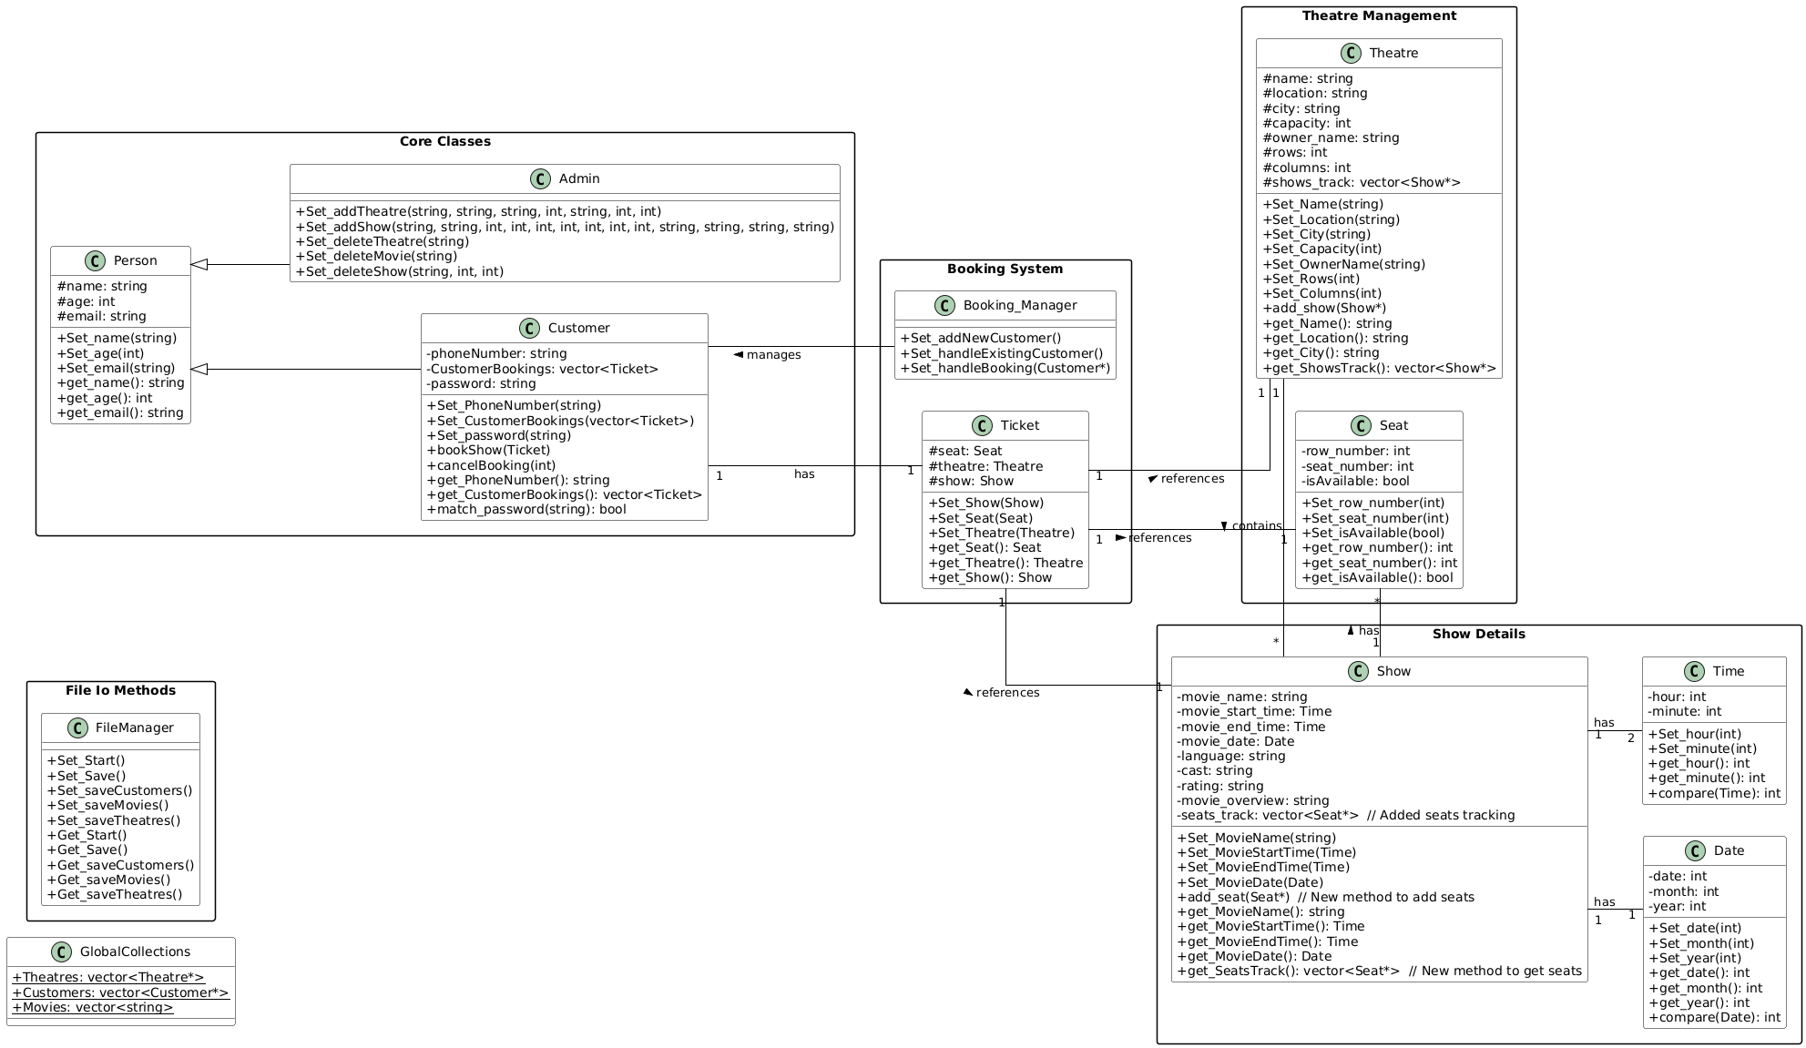

**7.** **Workflow:**  
The workflow diagram illustrates the system's process flow, showing the interactions between different components of the Movie Ticket Booking System, including:

* User registration and login
* Movie selection process
* Seat booking workflow
* Ticket confirmation steps
* Administrative operations

**Flow chart:**

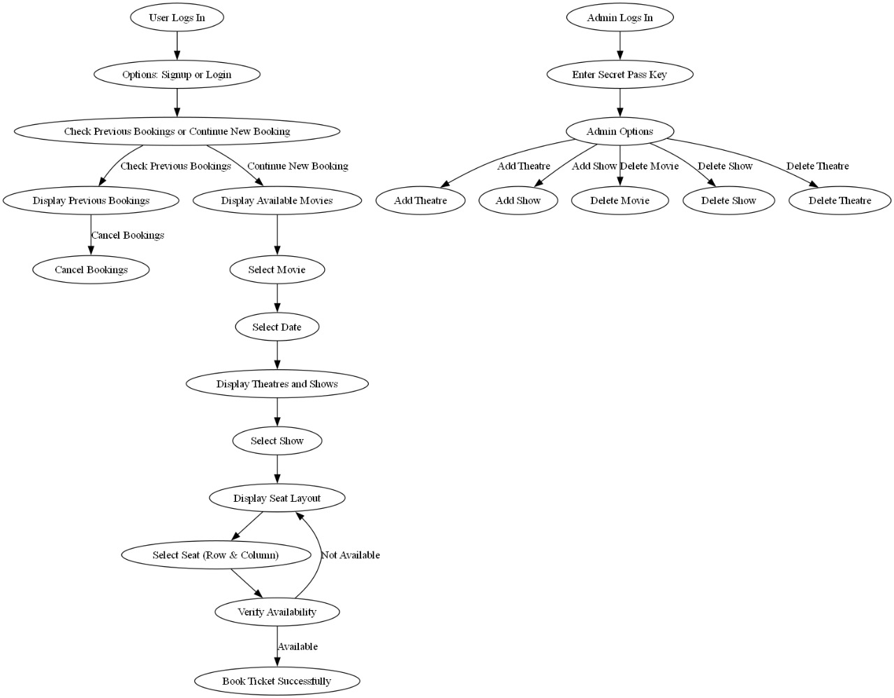

# 8. Important Files & Folders

* Key files in the project include:
  + BookYourShow.java:
    - Contains the main Java application logic and user interface for the terminal.
    - Acts as the entry point of the program.
  + core.cpp:
    - Implements the core backend logic for movie and seat management in C++.
    - Used for performance-critical operations.
* Data Files:
  + Customers.txt:
    - Stores user information, such as login credentials and booking history.
  + movies.txt:
    - Contains details about available movies, such as titles, genres, and showtimes.
  + Theatres.txt:
    - Holds information about theaters, including seating arrangements and availability.

# 9. Testing & Logging

We will implement unit tests for the core classes (Movie, Show, Seat, Booking) and use logging mechanisms to record booking failures and payment errors.

# 10. Conclusion

This project aims to develop a user-friendly movie ticket booking system with real-time seat availability, secure payment, and efficient booking confirmation. We expect to deliver a robust system that simplifies the movie ticket booking process for users.